1. **Create an array of 10 elements and print them using the for each loop.**

***Program :-***

**package** com.ust.test;

**public** **class** SbaQuestion1

{

**public** **static** **void** main(String[] args)

{

**int** [] arr = {2,4,6,8,10,12,14,16,18,20};

System.***out***.println("The array elements are :- ");

**for**(**int** i:arr)

{

System.***out***.println(+i);

}

}

}

***Output:-***

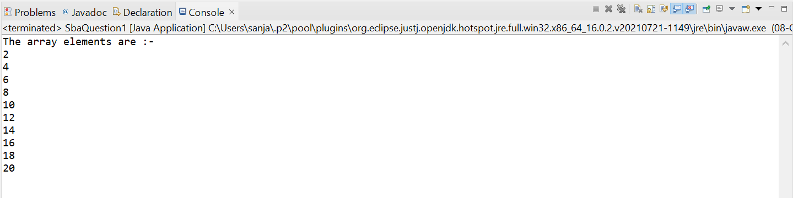

1. **Take the number input from the console and add all the positive numbers. (not to consider the negative number if entered)**

***Program :-***

**package** com.ust.test;

**import** java.util.Scanner;

**public** **class** SbaQuestion2

{

**public** **static** **void** main(String[] args)

{

Scanner sc=**new** Scanner(System.***in***);

System.***out***.println("Enter the number of elements :-");

**int** num= sc.nextInt();

**int**[] arr= **new** **int**[num];

**int** sum=0;

System.***out***.println("Enter the elements (Positive or Negative) :- ");

**for**(**int** i=0;i<num;i++)

{

arr[i]=sc.nextInt();

}

System.***out***.println("The elements are :- ");

**for**(**int** i=0;i<num;i++)

{

System.***out***.println(+arr[i]);

}

System.***out***.println("Calculating the sum of all positive numbers....");

**for**(**int** i=0;i<num;i++)

{

**if**(arr[i]>0)

{

sum+=arr[i];

}

}

System.***out***.println("The sum of all positive numbers are :- "+sum);

sc.close();

}

}

***Output:-***

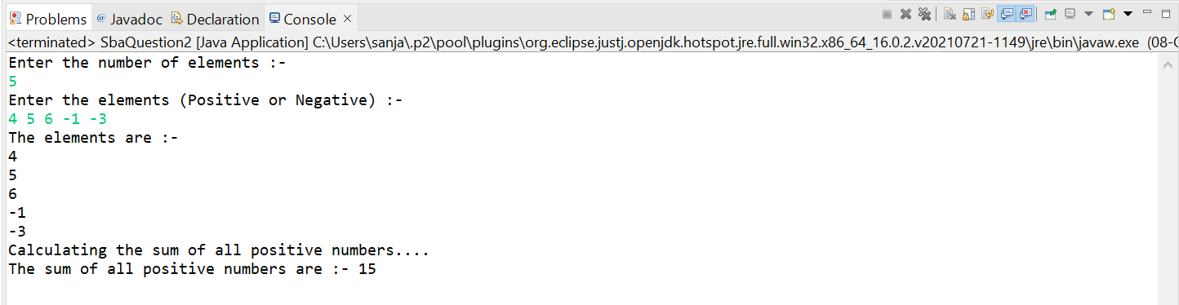

1. **Create a labeled break and write a simple logic and execute the program.**

***Program :-***

**package** com.ust.test;

**public** **class** SbaQuestion3

{

**public** **static** **void** main(String[] args)

{

**int** i=0,num=2;

label1:

**while**(num<20)

{

i++;

**if**(num==10)

{

**break** label1;

}

System.***out***.println("Number = "+num);

num+=2;

}

System.***out***.println("In iteration "+i+" the loop breaks");

}

}

***Output:-***

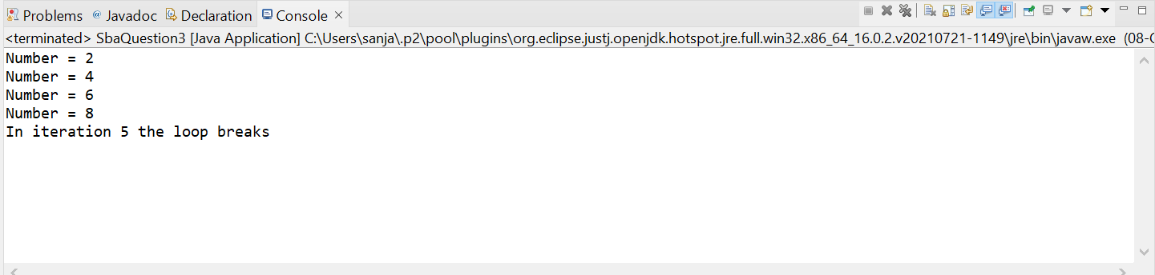

1. **Do the addition of around 10 even numbers, but use the continue statement in the logic.**

***Program :-***

**package** com.ust.test;

**import** java.util.Scanner;

**public** **class** SbaQuestion4

{

**public** **static** **void** main(String[] args)

{

Scanner sc=**new** Scanner(System.***in***);

System.***out***.println("Enter the number of elements :-");

**int** num= sc.nextInt();

**int**[] arr= **new** **int**[num];

**int** sum=0;

System.***out***.println("Enter the even numbers :- ");

**for**(**int** i=0;i<num;i++)

{

arr[i]=sc.nextInt();

}

**for**(**int** i=0;i<num;i++)

{

**if**(arr[i]%2==0)

{

sum+=arr[i];

}

**else**

{

**continue**;

}

}

System.***out***.println("The sum of all even numbers are :- "+sum);

sc.close();

}

}

***Output:-***

